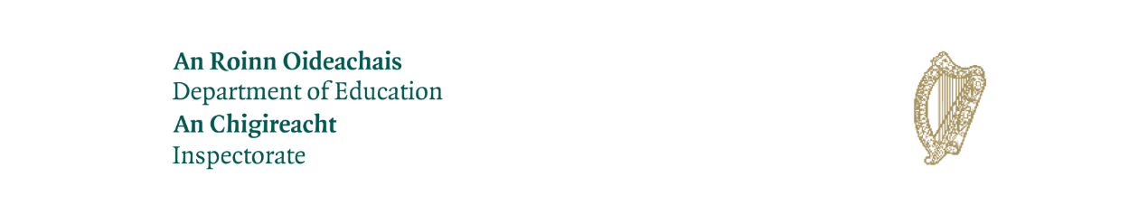
Evaluation in Primary Schools
Online Parent Survey

Dear Parent/Guardian,

The Inspectorate of the Department of Education is carrying out an evaluation in your child’s school. The evaluation looks at key aspects of the school’s work including its management and organisation, and the quality of learning and teaching. The process is designed to evaluate the work of the school and to promote school improvement. Further information on inspection for children, young people and for parents and guardians is available at https://www.gov.ie/en/publication/d3832-guide-to-inspection/

All data gathered as part of this evaluation will be processed in accordance with the Department of Education Data Protection Policy which can be accessed at https://www.gov.ie/en/publication/d78f2-department-of-education-privacy-notice/

What is a Whole School Evaluation?
If you would like information on Whole School Evaluations you can access a Guide to Inspections in Primary Schools and Special Schools at:

https://www.gov.ie/en/publication/61eafd-guide-to-inspections-in-schools/

Parent Survey
As part of the evaluation, you are invited to complete an online survey. The Inspectorate values your views on issues such as the atmosphere in the school, how you and your child feel about school and the quality of teaching and learning in the school.

The survey may be accessed by clicking on the following link:

https://dessurveys.education.gov.ie/surveys/WSE-Primary-Parents-Survey

You will first be asked to select your preferred language and then you will be required to enter the school’s roll number. Your school roll number is: 17300G

The survey will open on Friday 20th October and the deadline for completion of the survey is Friday 3rd November at 5pm.

What happens next?
The Whole School Evaluation will take place in your school on Monday 6th November until Wednesday 8th November. The report will be published on https://www.gov.ie/school-reports in due course.

Thank you most sincerely for your co-operation.

Mise le meas,
Úna Kingston.

